***Module:- 5) HTML 5***

**Q.1)What are the new tags added in HTML5?**

Ans:- There are seven types of new tags added in HTML5…

(1)The are seven type of HTML 5 tags , Followings are

(1)<header>

(2)<section>

(3)<footer>

(4)<audio>

(5)<video>

(6)<canvas>

(7)<svg>

Example=>

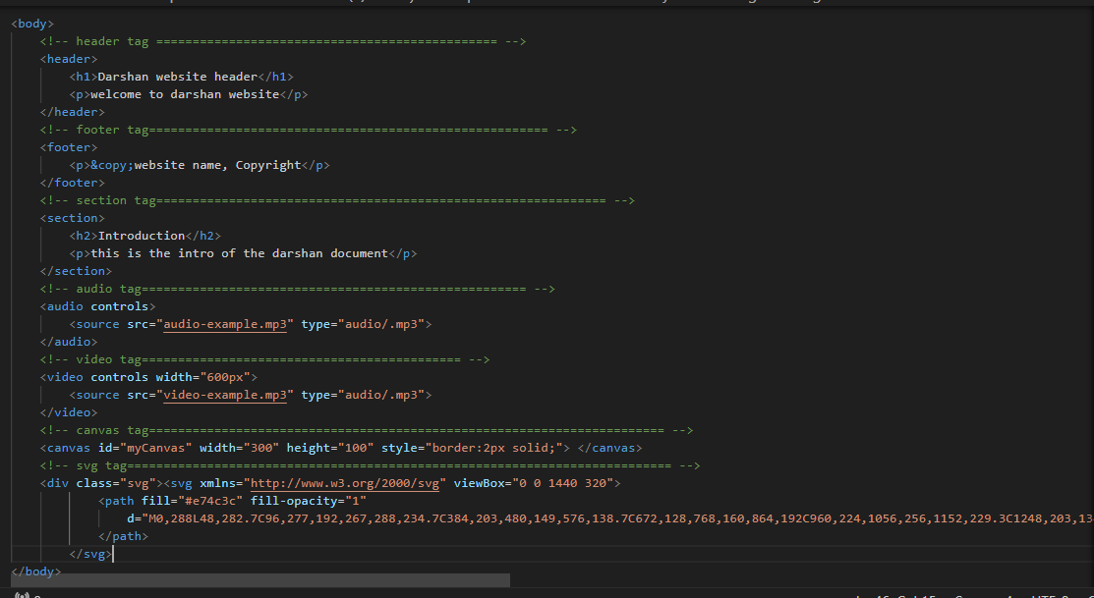

--------------------------------------------------------------------------------------------------------------------------------------

**Q.2) How to embed audio and video in a webpage?**

Ans:- Embed audio and video in a webpage, use the <audio> and <video> tags introduced in HTML5.

Here are examples for both:

* Audio Tag Example.

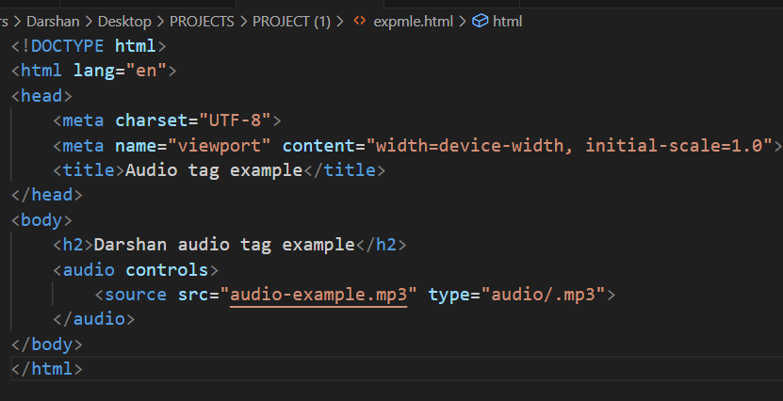

* Video Tag Example.

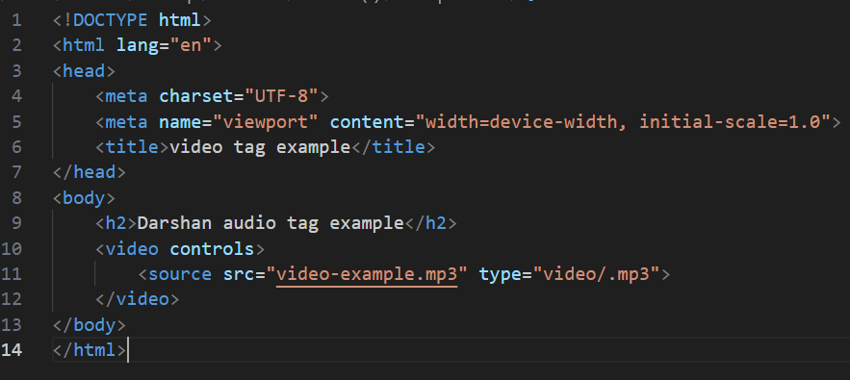

--------------------------------------------------------------------------------------------------------------------------------------

**Q.3) Semantic element in HTML5?**

Ans:-There are some semantic elements that can be used to define different parts of a webpage:

They provide a way to describe the role of different parts of the document, making it more accessible to both browsers and developers.

1)Header

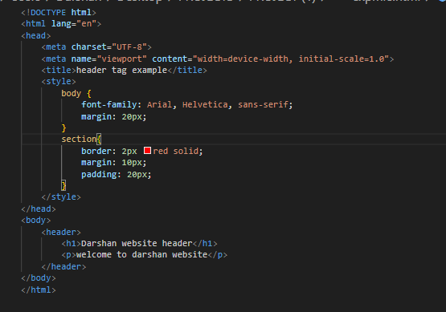

2)Navigation

3)Section

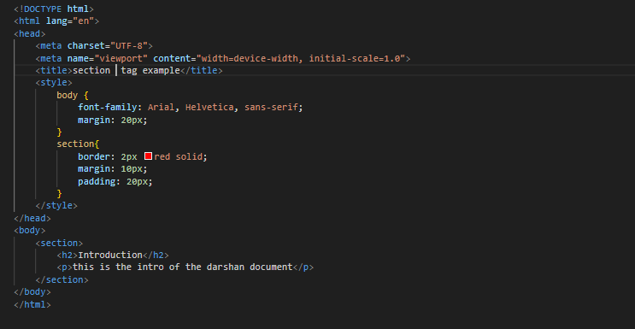

4)Footer

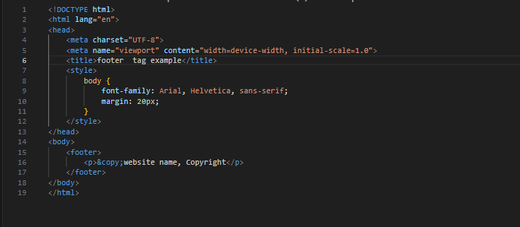

--------------------------------------------------------------------------------------------------------------------------------------

**Q.4)Canvas and SVG Tags.**

Ans:-Canvas:-Canvas Tag used to drawing area.

Ex..

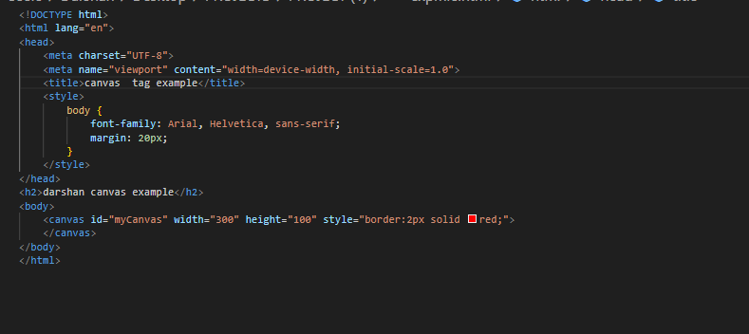

SVG Tag:- The <svg> element is used to create an SVG graphics container.

SVG elements like <rect>, <circle>, and <text> are used to draw a green rectangle, a purple circle, and black text on the SVG canvas.

Ex…

